GPS Display and Time/Grid Square Synchronization Source
Gene Marcus W3PM GM4YRE

This inexpensive and easy to build small battery powered device will not only provide time synchronization for the W3PM WSPR project, but makes an ideal pocket sized travel companion.

Displayed GPS parameters include:
- Time
- Day of the week and date
- Grid square
- Number of satellites in view
- Latitude and longitude
- Speed (knots, kph, mph)
- Altitude (meters and feet)
- Distance to home or other selected location (km and miles)
- Bearing to home or other selected location

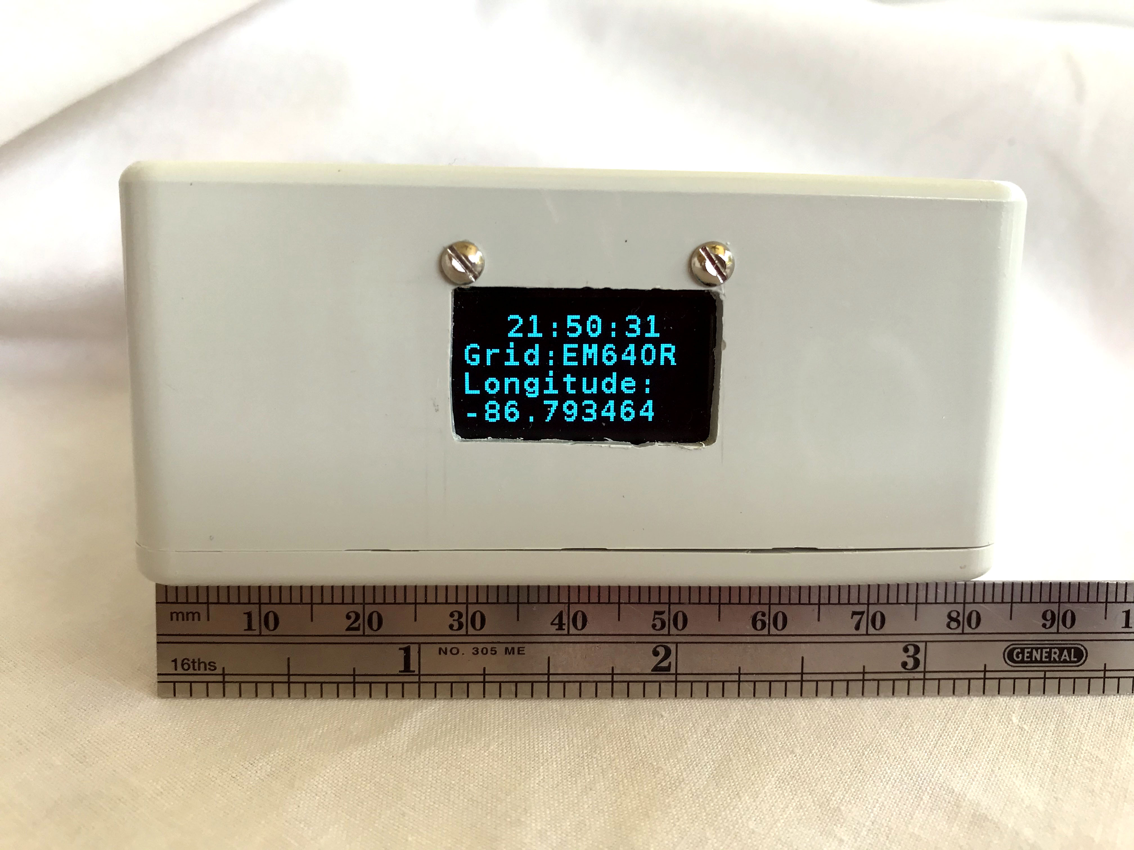

Figure 1.

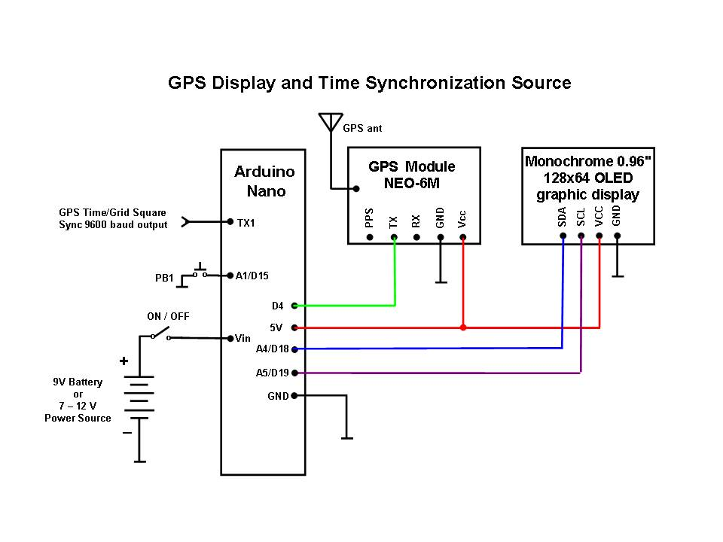
Figure 2.

Introduction

The NEO-6M GPS module was originally purchased to be part of my Auto-Calibrated RTC GPS WSPR Si5351A Project. Unfortunately, the NEO-6M GPS module would not function properly when the antenna was anywhere near the Si5351A module. Shielding did not solve the problem so the GPS module was placed in its own project box along with an Arduino Nano and OLED display. This turned out to be quite fortuitous because the external unit is now very sensitive and can used as a small self contained multifunction GPS display in addition to synchronizing the time and grid square location with the WSPR project.

The three main components for this project (Arduino Nano, NEO-6M GPS module, and the monochrome 0.96” OLED display) are readily available through popular internet providers at very competitive prices.

UTC time is continually displayed. All the other GPS parameters outlined above are displayed sequentially on the OLED display.

UTC time and six digit grid square location data followed by “#” are continuously outputted at 9600 baud at Arduino Nano pin TX1. The “#” character is used for synchronization by the WSPR sketch.

Construction

Construction of the unit is not critical. I first built the system using a solderless breadboard without any problems. The circuit (Figure 2) was then transferred to a piece of perfboard and placed in a box along with a 9 volt battery and an ON/OFF switch.

My unit is powered from a 9 volt battery connected to “VIN”. You can use the USB programming cable, a separate 5VDC source connected to the “+5V” pin, or 7-12VDC source connected to the Arduino Nano’s “VIN” pin to power your unit.

Software Installation and Setup

The Arduino download website <http://arduino.cc/en/Main/Software> outlines installation instructions for the first-time Arduino user.

The sketch requires two open source libraries; “SSD1306Ascii” by Bill Greiman and “TinyGPS++” by Mikal Hart. The “SSD1306Ascii” library is found in the Arduino IDE at; Sketch > Include Library > Manage Libraries (Windows users will find the menu bar on top of the active window. Linux and MAC users will find the menu bar at the top of the primary display screen.). Follow the instructions at http://arduiniana.org/libraries/tinygpsplus/ to install TinyGPS++” .

Operation

The display’s single pushbutton controls the geographical location for the distance and bearing parameters. Depressing the pushbutton will change the location of interest. This is a handy function for UHF/VHF operation in field to determine antenna aiming bearings back to home or any other desired location. Any number locations may be added within the sketch. Instructions to add additional locations are found within the sketch.

